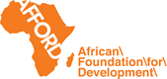
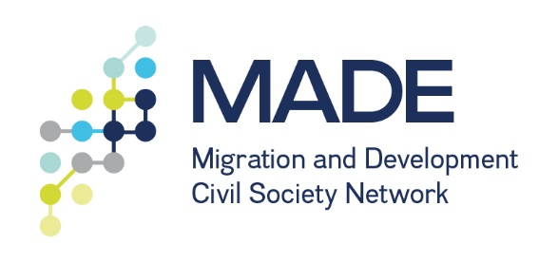

MADE West Africa
Match-Funding Contribution
2018-2019

Call for proposals

Small-scale grant in match funding for actions for the effective channelling of remittances for development and job creation in Ghana or Sierra Leone

Application Form

Please submit completed application form to richard@afford-uk.org before 20 August 2018.
Please use the eligibility criteria in the concept note of this call as the basis for your application.

- CONTACT INFORMATION

Name of the organization
Contact Person
E-mail address
Country
Address
Telephone number
Mobile number
Website
Facebook

- ORGANIZATIONAL BACKGROUND

B.1 Profile of your organization (max. 200 words)
Briefly describe your organization’s profile (mandate/ focus/ target groups/ geographical area/ organizations structure and number and type of staff/network)

B.2 Work experience on migration, diaspora and development (max 150 words)
Does your organization have experience in working with your national or city government for the development and job creation in your communities of operation? Are you currently involved in such actions? If yes, please provide one or two examples of past or current actions.

- ADVOCACY ACTION PROPOSAL

C.1 Title of the Action

C.2 Country(/ies), level of implementation and language
In which country(ies) will your action take place?
At what level (regional, national, local) is the action implemented?
In which language(s) will the activities be conducted?

C.3 Description of the activity (max. 500 words)
Provide a detailed explanation of your proposed action. What do you plan to do? And which government (departments) and key stakeholders do you plan to engage with and how?

C.4 Implementation period and dates
What is your proposed timeline? If relevant, identify potential target date(s) for your activity.

C.5 Objectives, results, indicators and impact (max. 200 words)
In a few bullets list the objectives for your action, the outputs and results you want to achieve, and how you will evaluate the results, using which indicators. Also describe the impact you expect your action to have on development and job creation in your communities of operation?

C.6 Partnership
Do you plan to collaborate with other organizations for this activity? If so, briefly describe the partnership and profile of the organizations/networks involve

- INDICATIVE BUDGET

An 8000 EUR will be allocated for each national advocacy activity. Please provide a detailed budget proposal. An example of a template you can use is provided below.

 | Budget item | Total Amount (in EUR) | Justification (explain the budget item and amount)
A | Human Resources
A.1 | Staff cost
A.2 | Consultancy costs
B | Costs
B.1 | Venue
B.2 | Equipment
B.3 | Meals
B.4 | Accommodation
B.5 | Transportation
B.6 | …
C | Printing and advocacy materials
C.1 | Printing advocacy report/tools
C.2 | Translation
C.3 | …
D. | Other costs
D.1 | ….
 | Total

- ANNEXES TO THE APPLICATION

Please submit:
- Your option for match funding, by indicating the kind (see the above 6 point list), the source and the approximate amount.
- Your documents of incorporation, registration, constitution, annual reports, audited financial report, bank details and statements

AFFORD
Rich Mix Building
35-47 Bethnal Green Road
Shoreditch, London, E1 6LA
Tel: + 44 (0) 203 326 3750
E-mail: richard@afford-uk.org
Website: www.afford-uk.org

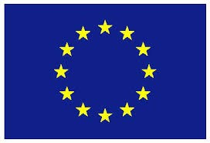
This project is co-funded by the European Union

Applicants must be non-profit organizations, businesses, diaspora led organisations working on the policy, advocacy migration, development, unemployment and job creation issues are eligible to apply.
This list should include Ghana or Sierra Leone
max. 30 % of the total budget may be used for human resources

